Ministry of Internal Affairs, P.O Box 2395, Nuku’alofa, Kingdom of Tonga Telephone: (+676) 7401010 Fax: (+676) 23671

SKILLS AND EMPLOYMENT FOR TONGANS (SET) PROJECT
PRESS RELEASE: 23 May, 2022: 3PM

(Nuku’alofa, 23rd May, 2022) The World Bank’s SET Project, implemented by the Ministry of Internal Affairs (MIA) and Ministry of Education and Training (MET), has disbursed $T$962,250.00 this afternoon for the payment of Term 1 secondary school fees, under its Conditional Cash Transfer (CCT) Program for disadvantaged families.
3849 eligible secondary students from 2173 households across Tonga will receive financial assistance for Term 1. Eligible households with up to three students will receive a direct deposit of $250 per student each term, into their bank accounts.
Of the total 3849 secondary student beneficiaries, 1996 are studying in Tongatapu, 839 in Vava’u, 495 in Ha’apai , 365 in Eua and 154 students in Niuafo’ou and Niuatoputapu.
The disbursement today, coincides with the resumption of all secondary school levels today Monday, 23 May, 2022.
Dr Fotu Fisi’iahi, CEO of Ministry of Internal Affairs, said “I am pleased to announce the term payment has been disbursed to all banks this afternoon. I would like to apologize to all our parents for the long wait. To all our students, I wish you the best as you return to school.”
He urged beneficiaries’ parents and guardians make the most of the SET Project funding opportunity. “Parents please ensure that the money is properly spent for educational purposes, your children are attending school and are well supported to succeed in their educational goals.”
Although MIA and SET Project had scheduled Term 1 payments to be made in February, the impact of the volcanic eruption and Covid19 on education in the last 4 months, made this impossible.
The SET Project Manager, Lilieta Takau said, “In response to the natural disasters and COVID19, the number of beneficiaries has increased this year from 3777 in Term 4, 2021 to 3849 this term. The World Bank SET Project continues to support Tonga’s most vulnerable families by paying for children’s school fees during these tough times.”
End

For more information please contact: Lilieta Takau, SET-Project Team Leader via email: teamleader@set-tonga.to or mob: phone 7719301, SET office: 6852211

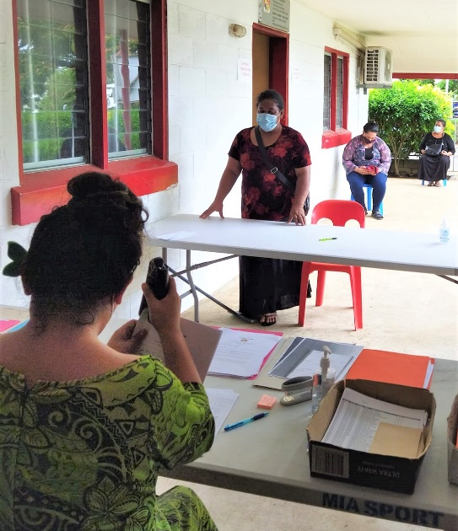  Enrolment during COVID19 restrictions, MIA main office, Nuku’alofa | 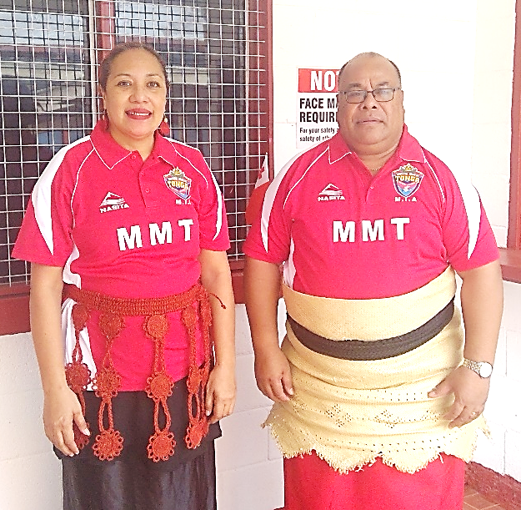  Lilieta Takau, SET Project Team Leader and Dr Fotu Fisi’iahi, CEO of Ministry of Internal Affairs
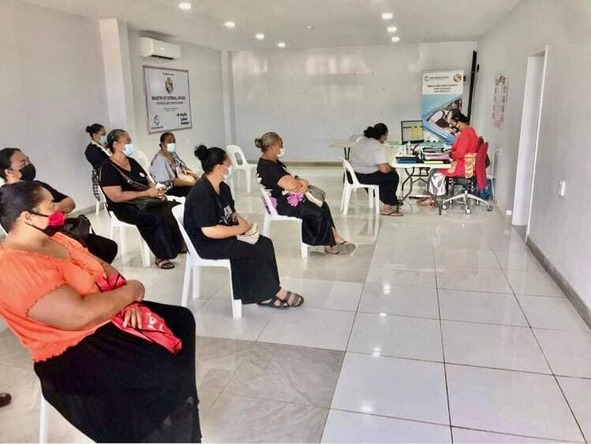
Vava’u beneficiaries completing enrolment at the MIA office in Neiafu

SET Project: Conditional Cash Transfer Program Term 1 Payment, 20 May, 2022
ISLAND DIVISION
Division | No. of Households  (Families) | No.of Students | CCT Disbursement (@$250)
Tongatapu | 1090 | 1996 | T$499,000.00
Vava'u | 473 | 839 | T$209,750.00
Ha'apai | 305 | 495 | T$123,750.00
Eua | 215 | 365 | T$91,250.00
Niua's | 90 | 154 | T$38,500.00
Total | 2173 | 3849 | T$962,250.00

